Section I: Scenario Demographics

Scenario Title: | Atrial Fibrillation and CHF in a patient with Aortic Stenosis
Date of Development: | 20/04/2016 (DD/MM/YYYY)
Target Learning Group: | Juniors (PGY 1 – 2) Seniors (PGY ≥ 3) All Groups

Section II: Scenario Developers

Scenario Developer(s): | Donika Orlich
Affiliations/Institution(s): | McMaster University
Contact E-mail (optional): | Donika.orlich@medportal.ca

Section III: Curriculum Integration

Learning Goals & Objectives
Educational Goal: | Expose learners to a patient with decompensated AS due to A. fib resulting in CHF
CRM Objectives: | - Demonstrates situational awareness by anticipating likely events and communicating these clearly with all team members
Medical Objectives: | - Demonstrates strong communication skills by communicating risks and benefits of procedural sedation and cardioversion with the patient and conducting a code discussion  - Initiates broad work-up for acute decompensation in the patient with AS  - Employs a tailored approach to hemodynamic resuscitation in the AS patient  - Employs a tailored approach to the management of CHF in an AS patient

Case Summary: Brief Summary of Case Progression and Major Events
A 78-year-old male presents with increased SOB over the past 4 days. A recent ECHO will be presented showing severe AS. The ECG will demonstrate new A Fib with a HR of 150 and the CXR will show CHF. The patient will be normotensive, at first, but will become hypotensive shortly after. The team will then need to decide whether to cardiovert the patient or attempt rate control. If these are done safely, the patient will respond and then develop worsening CHF. Definitive management should be sought with early cardiology/cardiac surgery consult. If management is not carried out judiciously, the patient will become profoundly hypotensive.

References
Marx, J. A., Hockberger, R. S., Walls, R. M., & Adams, J. (2013). Rosen's emergency medicine: Concepts and clinical practice. St. Louis: Mosby.
ACC/AHA/ESC 2006 guidelines for the management of patients with atrial fibrillation: Article accessed April 20, 2016. http://europace.oxfordjournals.org/content/8/9/651

Section IV: Scenario Script

A. Scenario Cast & Realism
Patient: | Computerized Mannequin |  |  |  |  | Realism:  Select most important dimension(s) |  |  | Conceptual
 | Mannequin |  |  |  |  |  |  |  | Physical
 | Standardized Patient |  |  |  |  |  |  |  | Emotional/Experiential
 | Hybrid |  |  |  |  |  |  |  | Other:
 | Task Trainer |  |  |  |  |  |  |  | N/A
Confederates | Brief Description of Role
Wife | Provides latest ECHO report from cardiologist. Present for code discussion. If no consent obtained prior to procedural sedation, she will ask about the risk.
B. Required Monitors
EKG Leads/Wires |  |  | Temperature Probe |  |  |  | Central Venous Line
NIBP Cuff |  |  | Defibrillator Pads |  |  |  | Capnography
Pulse Oximeter |  |  | Arterial Line |  |  |  | Other:
C. Required Equipment
Gloves |  |  | Nasal Prongs |  |  |  | Scalpel
Stethoscope |  |  | Venturi Mask |  |  |  | Tube Thoracostomy Kit
Defibrillator |  |  | Non-Rebreather Mask |  |  |  | Cricothyroidotomy Kit
IV Bags/Lines |  |  | Bag Valve Mask |  |  |  | Thoracotomy Kit
IV Push Medications |  |  | Laryngoscope |  |  |  | Central Line Kit
PO Tabs |  |  | Video Assisted Laryngoscope |  |  |  | Arterial Line Kit
Blood Products |  |  | ET Tubes |  |  |  | Other: BiPap
Intraosseous Set-up |  |  | LMA |  |  |  | Other:
D. Moulage
Old man mask.

E. Approximate Timing
Set-Up: |  | 5 min |  | Scenario: | 15 min |  |  | Debriefing: |  | 20 min

Section V: Patient Data and Baseline State

A. Clinical Vignette: To Read Aloud at Beginning of Case
A 78-year-old male presents via EMS with 4 days of increased SOB. The triage nurse comes to tell you she has put him in the resuscitation bay due to unstable vitals. HR was in the 150s. The O₂SAT was 86% on RA when EMS arrived, but is now 95% on a NRB.
B. Patient Profile and History
Patient Name: Geoff Miller |  |  |  |  |  | Age: 78 |  |  |  |  |  |  |  | Weight: 80kg
Gender: M F |  |  |  |  |  | Code Status: FULL
Chief Complaint: SOB
History of Presenting Illness: Increased SOB over the past 4 days. This morning he was severely SOB on awaking therefore wife called EMS.
Past Medical History: |  | “Valve Problem” |  |  |  |  | Medications: |  |  |  |  | Enalapril 5mg PO daily
 |  | HTN |  |  |  |  |  |  |  |  |  | Simvastatin 20mg PO daily
 |  | Dyslipidemia |  |  |  |  |  |  |  |  |  | Metformin 500mg PO BID
 |  | DM 2
Allergies: None
Social History: Lives with wife. No smoking. No EtOH
Family History: Nil.
Review of Systems: |  | CNS: |  |  | No syncope/presyncope
 |  | HEENT: |  |  | Nil
 |  | CVS: |  |  | Mild chest pressure last 4 days off and on. Worse on exertion. No radiation. No pedal edema. No palpitations. No history of angina, CHF or exertional syncope.
 |  | RESP: |  |  | Worsening SOB over past 4d. + orthopnea. No cough/sputum
 |  | GI: |  |  | Nil
 |  | GU: |  |  | Nil
 |  | MSK: |  |  | No calf swelling/pain. |  |  |  |  |  |  |  | INT:
C. Baseline Simulator State and Physical Exam
No Monitor Display |  |  |  | Monitor On, no data displayed |  |  |  |  |  |  | Monitor on Standard Display
HR: 150/min |  |  | BP: 105/50 |  |  |  |  | RR: 30/min |  |  |  |  |  |  | O₂SAT: 95% NRB
Rhythm: A.fib |  |  | T: 36.6ºC |  |  |  |  | Glucose: 10 mmol/L |  |  |  |  |  |  | GCS: 15 (E4 V5 M6)
General Status: Increased WOB but no significant distress.
CNS: | Nil
HEENT: | Nil
CVS: | Grade 3 SEM (crescendo-decrescendo) with rad to carotids. Pulsus parvus et tardus.
RESP: | Bilateral crackles
ABDO: | Soft. No ascites.
GU: | Nil
MSK: | No pedal edema |  |  |  |  |  |  |  | SKIN: | Normal

Section VI: Scenario Progression
Scenario States, Modifiers and Triggers
Patient State | Patient Status | Learner Actions, Modifiers & Triggers to Move to Next State
1. Baseline State  Rhythm: A. fib  HR: 150/min  BP: 105/50  RR: 30/min  O₂SAT: 95% NRB  T: 36.6ºC | Breathing quickly. Speaking in 3-4 word sentences. | Learner Actions  - IV, O2, monitors  - Labs (troponin, TSH, extended lytes, VBG, basic labs)  - Portable CXR  - ECG  - ASA 160mg PO  - Consider early BiPAP  - Code discussion | Modifiers  Changes to patient condition based on learner action  - Ask about PMHx wife gives copy of last ECHO  Triggers  For progression to next state  - BiPAP started, preparing meds for rate control, or 5 min into case 2. Hypotension  - Decision to cardiovert  3. Cardioversion
2. Hypotension  Rhythm: A. fib  HR: 150/min  BP: 80/60  RR: 20/min  O₂SAT: 98% on 50% | Decreased work of breathing on BiPAP. | Learner Actions  - 250cc NS bolus  - Repeat 250cc NS bolus  - Prepare for cardioversion  - ± Low-dose norepi (0.03 mg/kg/min)  - ± Amiodarone or digoxin for rate control  - Consult cardiology +/- cardiac surgery | Modifiers  - 250cc bolus BP 85/65, HR 145, O2 96%  - 500cc total bolus BP 90/70, HR 140, O2 90%  - Norepi BP 100/75, HR 140  - Amiodarone/dig given HR 100, BP 100/75  - BB/CCB used for rate control HR 100, BP 70/60  - If no rate control/cardioversion by 5 min RN to prompt “what’s the plan for his HR?”  Triggers  - Decision to cardiovert  3. Cardioversion  - Rate control attempted  4. Worsening CHF
3. Cardioversion  Vitals as per previous state | Patient concerned but agrees to cardioversion. | Learner Actions  - Consent for cardioversion  - Consider small (250cc) fluid bolus prior to sedation  - Push-dose phenylephrine at bedside  - ½ dose sedation (fentanyl ± midazolam)  - Synchronized shock | Modifiers  - Shock at <200J no change  - Shock at 200J converts to sinus rhythm HR 82, BP 100/80  Triggers  - Sinus rhythm achieved  4. Worsening CHF
4. Worsening CHF  Rhythm: a fib or NSR (as per previous state)  HR: 90  BP: 100/80  O₂SAT: 90% on 100%  RR: 30  **Labs given at beginning of state | Increased WOB.  Diaphoretic.  Audible crackles. | Learner Actions  - BiPAP (if not already)  - Lasix (10mg-40mg IV)  - Cardiac surgery consult  - Cardiology consult  - Anticipate need for intubation | Modifiers  - Nitro given BP 70/40  Triggers  END CASE PRN

Section VII: Supporting Documents, Laboratory Results, & Multimedia

Laboratory Results
Na: 140 | K: 4 |  |  | Cl: 105 |  | HCO₃: 25 |  | BUN: 5 |  | Cr: 80 |  |  | Glu: 5.5
Ca: 2.50 |  |  | Mg: 0.80 |  |  |  | PO₄: 1.20 |  |  |  | Albumin: 35
VBG |  | pH: 7.30 |  |  | PCO₂: 35 |  | PO₂: 95 |  | HCO₃: 25 |  |  | Lactate: 2.0
Troponin I: 40 |  |  |  |  |  |  | TSH: 2.5
WBC: 5.0 |  |  | Hg: 120 |  |  |  | Hct: 0.4 |  |  |  | Plt: 300

Images (ECGs, CXRs, etc.)
CXR: CHF  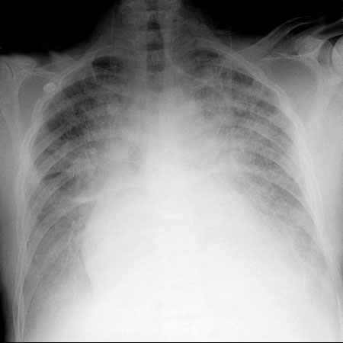  CXR source: https://www.med-ed.virginia.edu/courses/rad/  cxr/pathology2Bchest.html | ECG: LVH + A.fib  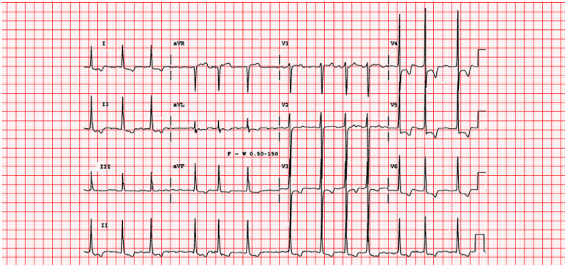  ECG source: http://www.wikidoc.org/index.php/  Atrial_fibrillation_EKG_examples
Lung U/S: B lines bilaterally (CHF) | ECG: NSR with LVH  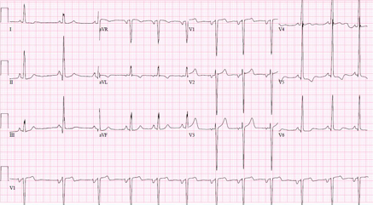  ECG source: http://bestpractice.bmj.com/best-practice/monograph/409/resources/image/bp/5.html
Section VIII: Debriefing Guide

General Debriefing Plan
Individual | Group |  | With Video | Without Video
Objectives
Educational Goal: |  | Expose leaners to a patient with decompensated AS due to A. fib resulting in CHF
CRM Objectives: |  | - Demonstrates situational awareness by anticipating likely events and communicating these clearly with all team members
Medical Objectives: |  | - Demonstrates strong communication skills by communicating risks and benefits of procedural sedation and cardioversion with the patient and conducting a code discussion  - Initiates broad work-up for acute decompensation in the patient with AS  - Employs a tailored approach to hemodynamic resuscitation in the AS patient  - Employs a tailored approach to the management of CHF in an AS patient
Sample Questions for Debriefing
- What was your approach to managing the A.fib in this patient? Were they stable or unstable?
- What factors did you consider when deciding whether or not to cardiovert this patient?
- What modifications to your management of CHF did you make for this patient with AS? Why?
- What is your approach to managing hypotension in a patient with AS?
Key Moments
- Recognition of unstable a fib and need for cardioversion.
- Tailored approach to hypotension and CHF in the patient with AS
- Safe procedural sedation planning

Supplemental ECHO

Cardiac Ultrasound Unit

Patient Name: Geoff Miller Age: 78 Sex: Male
Location: outpatient Indication: Reassess aortic stenosis

M-MODE AND TWO DIMENSIONAL FINDINGS

Left ventricular size is increased. Left ventricular function is slightly reduced, with an estimated EF of 35%. Septal motion is normal. The left atrium is mildly dilated. Right ventricular function is normal. There is no pericardial effusion.

SPECTRAL AND COLOR FLOW DOPPLER FINDINGS

There is moderate aortic stenosis with aortic root diameter measured at 0.9 cm. There is decreased maximum Aortic Velocity measured at 3mmHg, with a mean pressure gradient of 30mmHg. There is no mitral or tricuspid regurgitation.

CONCLUSION

Reduced left ventricular function with an EF of 35%
Dilated left ventricle
Dilated left atrium
Severe aortic stenosis with root diameter of 0.9 cm
No pulmonary hypertension
Compared to study 2 years ago, there is worsening of aortic stenosis with increased mean peak pressure gradient and decreased aortic root diameter

